**DATA:**

* The Health food data is about the People preferences when it comes to Health Drinks.
* The sample Size is 40.

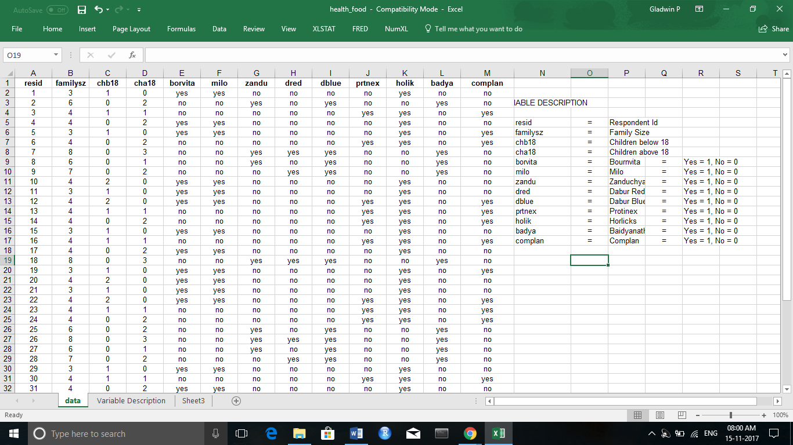

**DENDROGRAM (BETWEEN GROUPS)**

* Dendrogram shows the No of Clusters or Groups that exist among the Sample Chosen.
* The no of Clusters in this case can be limited to 3 since the Sample size is 40 - a smaller count and choosing the Cluster size as >3 would not be of greater use.

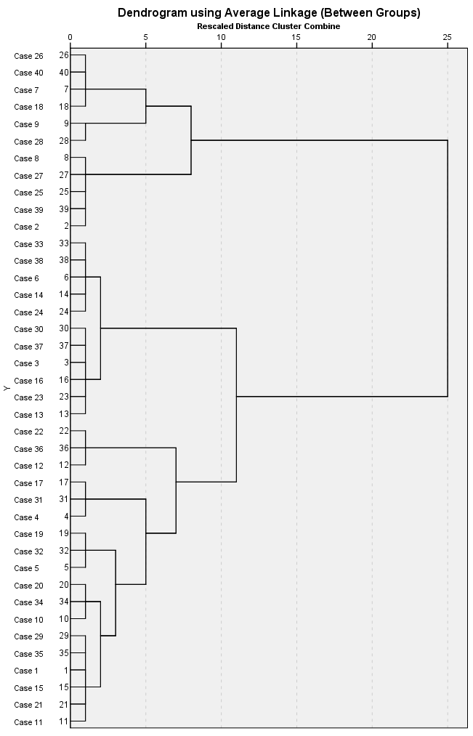

**FINAL CLUSTER CENTERS:**

* In the table below, considering the cluster 1 (2nd Column) 2 is max value other than Family size. So, it shows that the Children in the First Cluster prefer Bournvita, Milo, Horlicks.
* Considering the Cluster 2, the max value is 2. So, it shows that the children in the Second Cluster are Above 18 years of age and prefer Zanduchyawanprash, Dabur Red, Dabur Blue and Baidyanath.

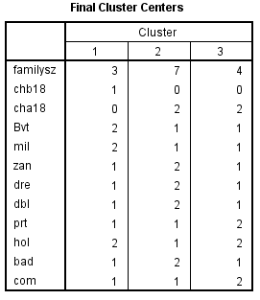

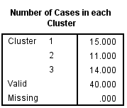

**CLUSTER DISTRIBUTION**

* This table shows the Cluster Distribution, about how many Children fall under each Cluster.

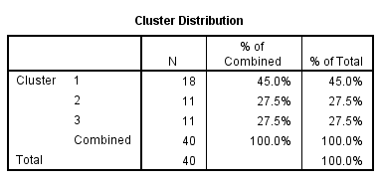

**FREQUENCIES**

* The Frequency Table shows the Number of Children preferring a Health drink falling under Each Cluster.

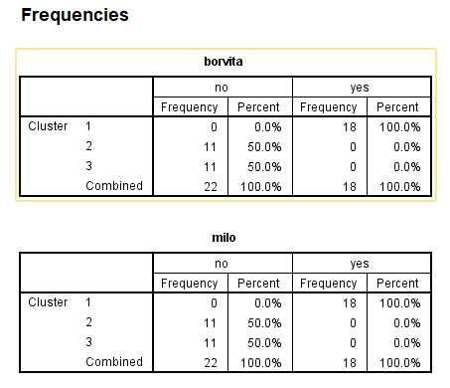

**MODEL SUMMARY:**

* The Model summary gives the Algorithm used i.e. Two Step and number of Clusters considered i.e. 3.
* The Cluster Quality shows the measure of Cohesion and Separation between the Clusters. The Cluster quality is rated as Good with a measure of around 0.65

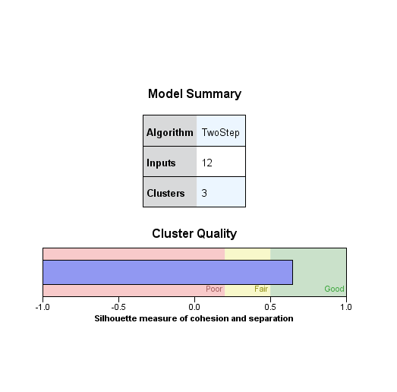

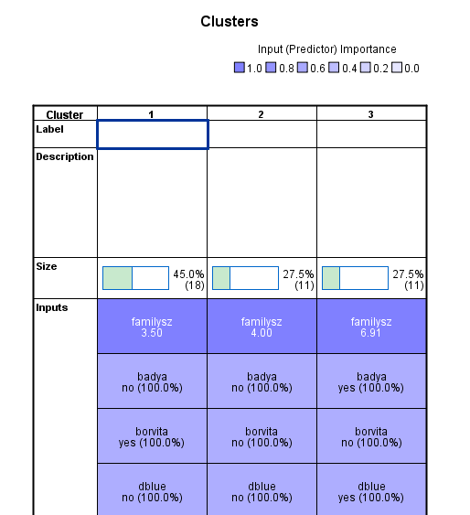

The above figure shows the Size of each Cluster and Input(Predictor) importance.

**CLUSTER SIZES**

* The below Pie Chart shows the Cluster Distribution in terms of percentage (%).
* The table below the pie chart gives the Size of the largest and smallest Cluster.

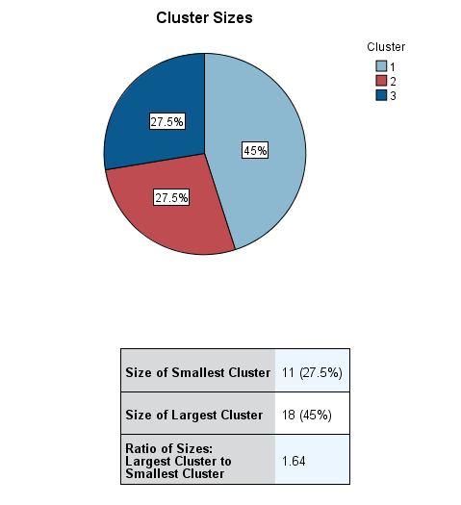

**PREDICTOR IMPORTANCE**

* The Predictor Importance Bar chart shows the Variables which are of Greater importance.
* The Family Size seems to be the most important predictor with the value of 1.

1. **Least Important**
2. **Most Important**

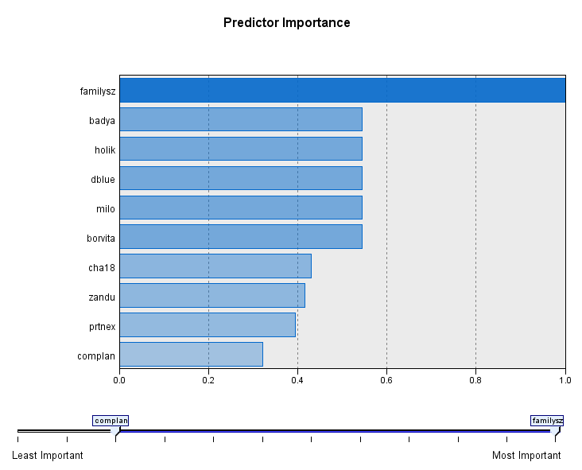

**CONCLUSION**

* The predictor importance chart tells us that the Children choice of Health Drinks depends mainly on the Family Size.